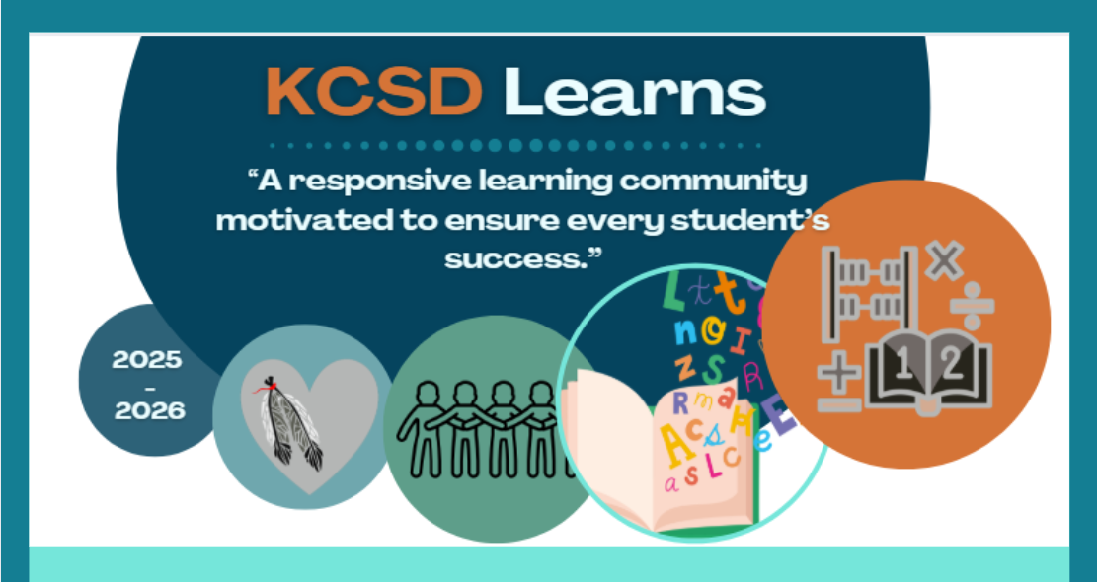

K-7 COMMUNICATING STUDENT
LEARNING GUIDELINES



September 2025

Table of Contents
Context: 3
BC’s Redesigned Curriculum: 3
Concept-based, competency-driven curriculum 3
Flexible Learning Environments 3
Purpose 4
Student Reporting: 4
What is Quality Classroom Assessment? 4
Reporting Schedule K-7 5
Informal Learning Updates (formerly called Interim Reports) - 2 per year 5
K-9 Formal Learning Updates (formerly called Report Cards) 5
Formal Learning Updates- 2 per year 6
Provincial Proficiency Scale 7
Provincial Proficiency Scale Indicators 8
Guidance for Curricular Areas to Report on and Provide Feedback in Elementary K-5 10
Guidance for Curricular Areas to Report on in Elementary 6+7 11
Guidance to Support Ongoing Student Learning and Reporting 12
Descriptive Feedback 13
Teacher feedback on areas for future growth 13
Separation of learning habits and engagement from academic reporting 14
Communicating about learning habits and engagement 14
Optional sentence stems for descriptive feedback: 15
Examples of descriptive feedback 15
Core Competencies & Goal Setting 19
Engagement for Success 21
Considerations for Students on Individualized Education Plans (IEPs) 22
Considerations for English Language Learners 23
Considerations for Insufficient Evidence 24
Formal Learning Update Guidelines: 25
Formal Learning Update Example 1: 27
Formal Learning Update Example 2: 29

KOOTENAY-COLUMBIA SCHOOL DISTRICT 20 (KCSD)
K-7 STUDENT REPORTING GUIDELINES

Context:
Since 2016, the province as been exploring alternate ways to communicate student learning to families. In 2023, the BC Ministry of Education and Child Care released a new K-12 Reporting Policy Framework. The new framework provides Kootenay-Columbia School District (KCSD) with the opportunity to build upon current reporting practices and create more consistency across all schools.

BC’s Redesigned Curriculum:
As explained in the BC redesigned curriculum, all areas of learning are on based on a “Know-Do-Understand” model to support a concept-based competency driven approach to learning.
Three elements, the content (know), the curricular competencies (do) and big ideas (understand) work together to support deeper learning.
Content (Know) | Detail the essential topics and knowledge at each grade
Curricular Competencies (Do) | The skills, strategies, and processes that students develop over time. While curricular competencies are more subject-specific, they are connected to the Core Competencies
Big Ideas (Understand) | The Big Ideas consist of generalizations, principles, and key concepts important in an area of learning. The big ideas represent what students will understand at the completion of the curriculum for their grade.

Concept-based, competency-driven curriculum

BC’s redesigned curriculum is flexible and focuses on literacy, numeracy and the First Peoples Principles of Learning. It blends two features that are essential for 21st century learning: a concept-based approach to learning and a focus on the development of competencies, to foster deeper more transferable learning. The two approaches complement each other because of their focus on active engagement of students. Deeper learning is better achieved through “doing” than through passive listening or reading. Similarly, both concept-based learning and the development of competencies engage students in authentic tasks that connect learning to the real world.

Flexible Learning Environments
Learning can take place anywhere, not just in classrooms. Many schools and teachers create learning environments that explore the use of time and space in creative ways. The integration of areas of learning and technology have opened the door for teachers and schools to approach the use of time and space in creative ways – ways that adapt to the students’ needs and interests. The Ministry of Education defines the “what” to teach but not the “how to organize the time, space or methods to teach it.
The curriculum website will continue to evolve in ways that support planning for learning. Check out the following search engine that allows teachers to search for key words or select key elements from specific grades or areas of learning. See: https://curriculum.gov.bc.ca/curriculum

Purpose
The primary purpose of ongoing student reporting is to effectively communicate learning with families to highlight where students are at in their learning, what their next steps are, and how families and school staff can work together to support students in their ongoing learning journey.

Teachers and students communicate student learning with families throughout the school year through a variety of formats. Some examples include sending home learning evidence, providing progress reports, hosting open houses or celebrations of learning, having in-person or virtual discussions, sharing digital or paper-based portfolios, etc.
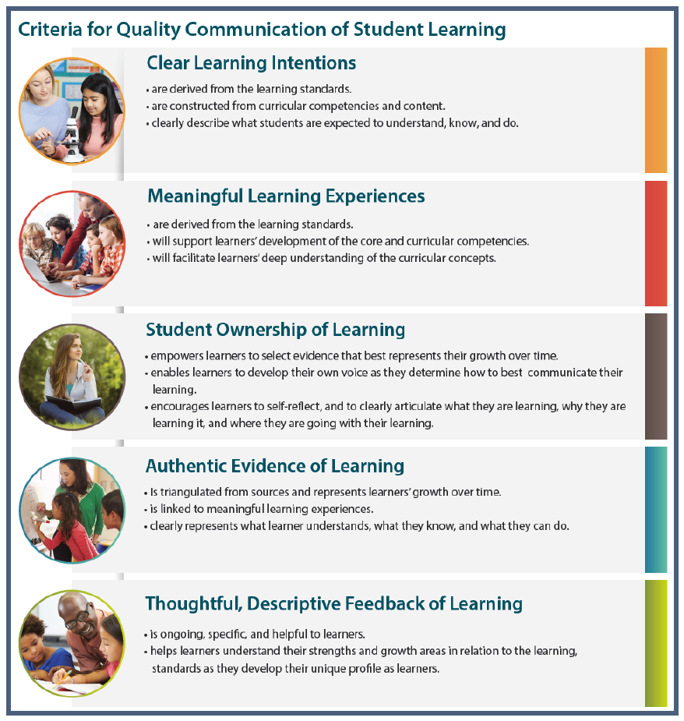

Student Reporting:

The goal of communicating student learning is:
- To ensure students take part in meaningful conversations that help them develop responsibility for engaging deeply with their learning.

- To ensure parents and caregivers are well informed, are involved in decisions and dialogue about their child’s learning and understand ways to support and further their child’s learning.

What is Quality Classroom Assessment?
* K-9 Student Reporting Guidelines, Central Okanagan Public Schools

- Is responsive to all learners
- Embeds Content, Curricular Competencies and Big Ideas (Know, Do, Understand)
- Provides ongoing descriptive feedback
- Provides opportunity for learners to demonstrate learning in a variety of ways and multiple times
- Provides students, parents and caregivers with a clear understanding of where the student is in their learning
- Has student setting goals for future learning
- Involves students in their learning and promotes self-assessment and goal setting for next steps in learning
- Allows for a collection of student work to be gathered over time to provide a full profile of the learner and learning
- Communicates clearly where the learner is, what they are working towards, and the ways learning can be supported
- Click here to read the ministries Classroom Assessment & Reporting Guide

Reporting Schedule K-7

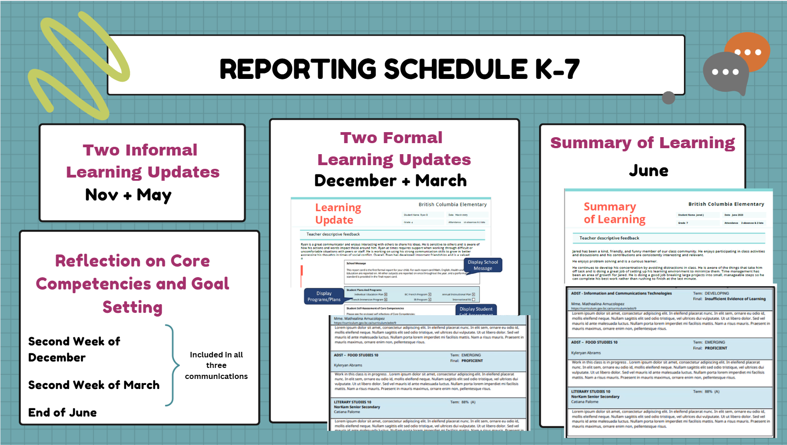

Informal Learning Updates (formerly called Interim Reports) - 2 per year
Examples of Informal Learning Update may include:
Conferences Virtual discussions Telephone calls Emails Written Summaries
The intention of an informal learning update is to provide parents/guardians with responsive and timely information about where their child is in their learning, heighten their awareness of their child’s abilities and learn about way they can support their child’s progress.
KCSD learns invites teachers to consider the following Informal Learning Update Template when planning to provide families with an informal learning update. Check in with PVP who also have templates available.

Please let your PVP know how you have completed your informal learning update (Nov. and May) and keep all evidence.

K-9 Formal Learning Updates (formerly called Report Cards)
When creating Formal Written Learning Updates for families:
- be clear and concise
- empower students in taking ownership of their learning
- use family-friendly language
- be strength-based and focus on each unique student as a whole learner
- provide an overview of areas of growth and next steps in learning
- be consistent and aligned across classrooms, grades, and schools

Formal Learning Updates- 2 per year

Written Formal Learning Updates and the Summary of Learning (formerly called report cards) are ministry required learning updates that are provided to families throughout the school year as a way of communicating student progress.
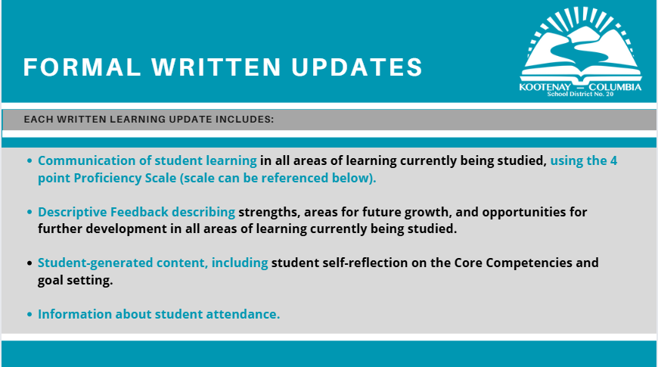

Please note: In all elementary schools, English Language Arts and Français Langue, “Reading, Listening, & Viewing” and “Writing, Speaking, & Representing” are reported on separately using the Proficiency Scale.

Ways to Support Learning
Written Learning Updates and Summary of Learning must include how the student will be supported to further their learning. KCSD Learns invites staff to comment about individualized supports within the classroom and suggested ways to support student learning at home.
The communication could be framed like - In class,
- … will have opportunities to…
- … is encouraged to ask for help when …
- … can practice
- … will benefit from…
- … is encouraged to continue…

When creating Summary of Learning in June, teachers MUST enter term proficiency AND final proficiency in MyED BC. Final Proficiency column needs to be completed to generate the permanent student record card.

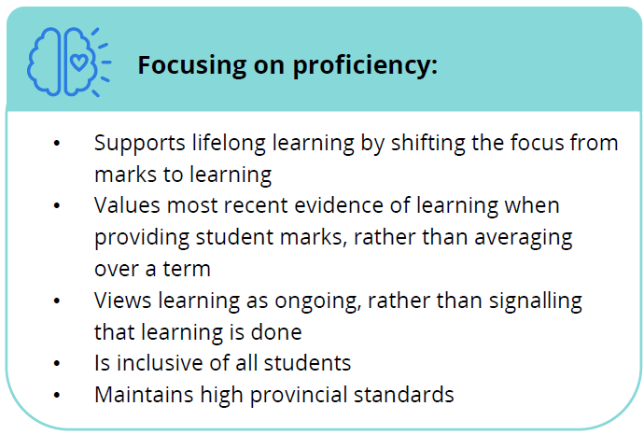
Provincial Proficiency Scale
The proficiency scale is intended to reflect student achievement in relation to the widely held grade level standards for that point in the school year. This assessment is based on achievement only. Factors such as behaviour are important and should be communicated through conversations and written descriptive comments on the report card. Behaviour should not be used to determine student’s achievement in relation to the widely held grade level expectations.

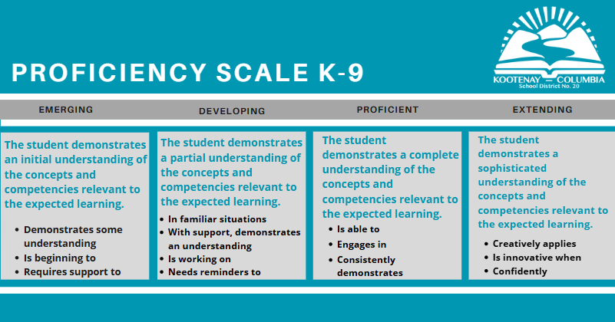
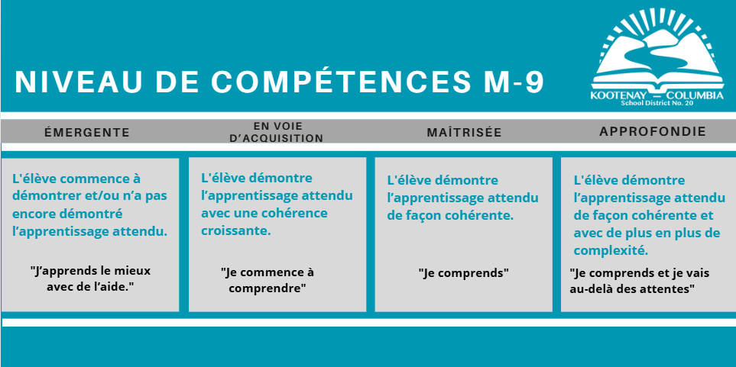

Provincial Proficiency Scale Indicators
Students come into learning situations with their own experiences and background knowledge. Students do not necessarily begin at Emerging or Developing at the beginning of each school year. Similarly, students do not always reach Proficient at the end of the school year. It is also important to recognize that obtaining Proficient is not the end of learning; if a student enters a learning experience with Proficient understanding or achieves Proficient during the school year, the aim becomes to dig deeper and to reach toward Extending their understanding. Every student has a place on the scale at any given time! As stated in the Reporting Guidelines:
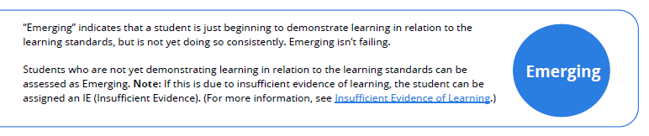

Teachers can support students who are Emerging to move toward Developing through a variety of strategies, including but not limited to:

- Connecting with a student to understand what they know, do, and understand in the area of learning to identify any knowledge gaps that need to be addressed before they are able to fully engage in their learning (e.g., a student who is struggling to decode may still be working to build the sound-symbol connections they need)
- Conferencing with a student to collaboratively decide how to move them forward in their learning in a way that is meaningful to them
- Differentiating their instruction
- Providing opportunities for a student to show their learning in a variety of ways
- Using assessment supports such as:
  - Being transparent about learning intentions
  - Setting goals and expectations and clearly communicating them
  - Building community and relationships
  - Co-constructing criteria with the student
  - Setting all students up for success by considering student context and needs
  - Using digital and/or audio texts or peer or adult helpers to assist with reading
  - Ensuring that the workspace is set up appropriately and is conducive to their needs (e.g., choice of chairs, augmented keyboard or mouse, screen magnifier, slant boards, alternate writing tools)
  - Presenting information in various formats (e.g., pictures, videos, print, audio)
  - Providing templates and graphic organizers
  - Using assistive tools and technology (e.g., word processor, calculator, text to speech/voice to text software, magnifier, FM system, video-recording answers, audio-recording answers)
  - Providing alternative ways of demonstrating knowledge (e.g., oral exams, projects instead of tests, podcasts or videos instead of presentations)
  - Extending time to complete assignments or tests
  - Taking breaks
  - Providing options for self and/or peer assessment
  - Offering feedback to inform revisions and improvements for reassessment
  - Collaborating with school supports, such as inclusive education, if a student is routinely emerging in an area of learning

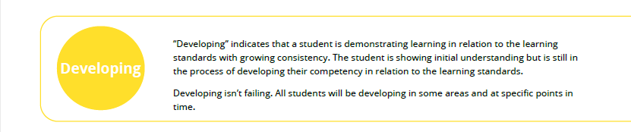

Teachers can support students who are Developing to move toward Proficient through a variety of strategies, including but not limited to:

- Connecting with a student to understand what they know, do, and understand in all areas of learning and using those strengths to further their learning (e.g., a student who has a strong interest in art but is struggling with symmetry in math could demonstrate their learning by creating a butterfly with symmetrical wings)

- Conferencing with a student to collaboratively decide how to move them forward in their learning in a way that is meaningful to them
- Providing students with strategies and tools that can help them in their areas for future growth
- Providing students with more opportunities to practise their learning to develop greater consistency and independence
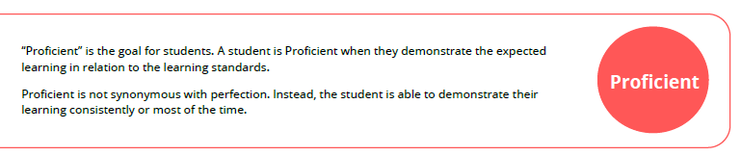
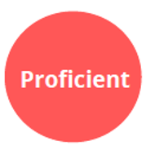
Teachers support all learners with their ongoing growth, including supporting students who are Proficient in moving toward Extending.
Teachers can support students in Extending in many ways. Here are some examples of how students can demonstrate their learning with greater depth and complexity:

- Demonstrating their learning in a variety of ways (e.g., a student can demonstrate several different ways of analyzing and interpreting data)
- Applying their thinking further (e.g., a student who is comparing two eras in history adds an in-depth comparison of both historical eras with the current era)
- Applying their learning to other curricular areas (e.g., a student incorporates mathematical concepts in their artwork)
- Exploring more complex learning standards (e.g., the class is learning about patterns, and a student is exploring more advanced concepts, such as quadratic equations)
- Connecting their learning with their local and/or global community (e.g., a student who is learning about the environment takes on environmental activism in their community)
- Supporting the learning of others (e.g., a student takes a lead role in teaching other students dance concepts in Physical Education)

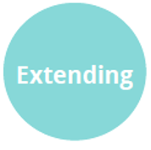
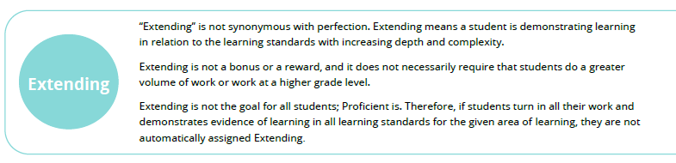

Teachers can support students in extending in many ways:
- By demonstrating their learning in multiple ways (student is able to demonstrate multiple ways of analyzing and interpreting data).
- By applying their thinking further (student comparing two eras in history adds an in-depth comparison of both the historical eras with our current era)
- By applying their learning into other curricular areas (student incorporates mathematical concepts in their artwork
- By exploring more complex learning standards (the class is learning about increasing patterns and a student explores patterns that grow in more complex ways).
- By connecting their learning to their local and/or global community (student learning about the environment takes on environmental activism in their community).
- By supporting the learning of others (student takes a lead role in teaching other students dance concepts in Physical Education).

Guidance for Curricular Areas to Report on and Provide Feedback in Elementary K-5
* Language Arts, Math, Science, Social Studies, Arts Education and Physical Health Education are taught consistently throughout the year. A Proficiency Scale Indicator and descriptive feedback are required for these subject areas on both Formal Learning Updates (Dec. and March) and the Summary of Learning (June).*

English |  |  | French
Course Code | Curricular Area |  | Course Code | Curricular Area
MEN | English (Reading, Listening, Viewing) |  | FFRAL | Français Langue (Reading, Viewing)
MEN | English (Writing, Speaking, Representing) |  | FFRAL | Français Langue (Writing, Representing)
MMA | Mathematics |  | MEN | English (Reading, Listening, Viewing) (gr. 4 & up)
MSC | Science |  | MEN | English (Writing, Speaking, Representing) (gr. 4 & up)
MSS | Social Studies |  | MMA | Mathematics
MPHE | Physical Health Education |  | FMTHF | Mathématiques
MAE | Arts Education |  | FEAF | Éducation Artistique
 |  |  | FSCF | Sciences
 |  |  | FSCHF | Sciences Humaines
 |  |  | FEPSF | Éducation Physique et Santé

Guidance for Curricular Areas to Report on in Elementary K-5 (cont.)
* Core French (beginning in grade 5), Career Education and Applied Design Skills & Technology are taught at various times of the year. A Proficiency Scale Indicator and descriptive feedback are required for these subject areas on on at least one Written Learning Update (Dec. or March) and the Summary of Learning (June).*
English |  |  | French
Course Code | Curricular Area |  | Course Code | Curricular Area
MFR | Core French (gr. 5 & up) |  | FEAF | Éducation Artistique
 |  |  | FECF | Éducation à la Carrière
MCE | Career Education |  | FCCPT | Conception Compétences Pratiques et Tech.
MADST | Applied Design, Skills & Tech.
For any curricular areas not being reported on in a given term, include the following comment: This curricular area is not being reported on this term.

Guidance for Curricular Areas to Report on in Elementary 6+7
*All subject areas are taught consistently throughout the year in grade 6 and 7. A Proficiency Scale Indicator and descriptive feedback are required for these subject areas on both Formal Learning Updates (Dec. and March) and the Summary of Learning (June).*

English |  |  | French
Course Code | Curricular Area |  | Course Code | Curricular Area
 |  |  | FFRAL | Français Langue Seconde (Immersion)
MEN | English Language Arts |  | MEN | English Language Arts
MMA | Mathematics |  | FMTHF | Mathématiques
MSC | Science |  | FSCF | Sciences
MSS | Social Studies |  | FSCHF | Sciences Humaines
MFR | Core French
MPHE | Physical Health Education | OR | FEPSF | Éducation Physique et Santé
MAE | Arts Education | OR | FEAF | Éducation Artistique
MCE | Career Education | OR | FECF | Éducation à la Carrière
MADST | Applied Design, Skills & Tech. | OR | FCCPT | Conception Compétences Pratiques et Tech.

*In the Gr. 6-7 French Immersion: Physical & Health Education, Arts Education Courses, Career Education, and/or ADST courses may be taught in English or French depending on available staffing/offerings.

Guidance to Support Ongoing Student Learning and Reporting

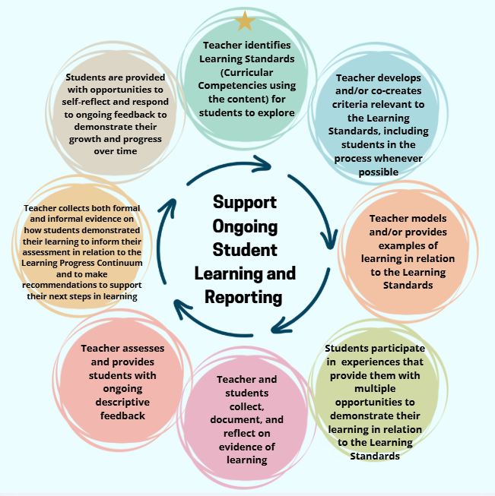
* K-9 Student Reporting Guidelines, Central Okanagan Public Schools

Descriptive Feedback

All written descriptive comments should use a strength-based approach and clearly describe students’ strengths as well as areas for improvement in relation to grade level learning standards. As shared in the K-12 Student Reporting Policy, teachers are invited to use the following guidelines for the creation of comprehensive feedback:
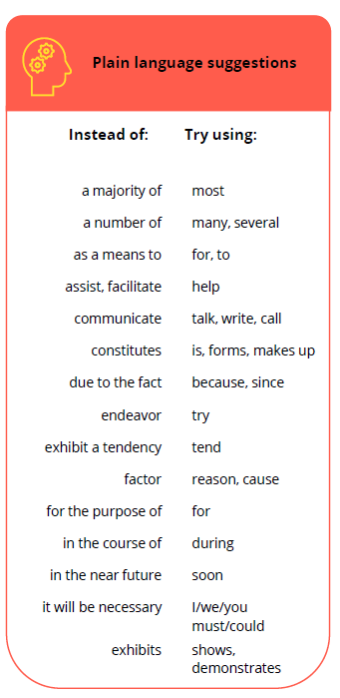
- Write meaningful feedback that refers specifically to the student’s strengths and areas for future growth.

- Include information on goals a student can work toward, both at school and at home.

- When commenting on areas for future growth, focus on what the student can do at that point in time (e.g., “Frances has a good grasp of sentence structure but continues to work on using punctuation correctly”).

- Provide information on specific supports a student is receiving or could receive to move them forward in their learning.

- Describe ways in which the student’s learning will be further supported by the teacher, and how parents and caregivers might help.

- Provide evidence by connecting feedback with examples from the classroom.

- Explain how the student approaches the learning process.

- Anticipate questions parents and caregivers may ask about their child’s growth and learning.

- Use plain language, since parents and caregivers may vary widely in their educational experiences, familiarity with educational terms, and levels of English language proficiency.

Teacher feedback on areas for future growth

Teachers should provide written feedback that communicates areas for future growth, provides specific examples, and describes ways to support further development. Written feedback on areas for future growth should be accompanied by feedback on student strengths, and how these strengths can be used to support the student in their areas for future growth.

“When directing attention to areas for future growth, a student’s self-reflection on Core Competencies and Goal Setting becomes important. Involving students in the process of setting goals in areas where they need further development and working toward those goals is an important part of the learning process and development of the whole child.” (Reporting Policy Guide pg. 40).

Separation of learning habits and engagement from academic reporting
Assessment feedback should be in relation to the learning standards alone. Learning habits and engagement should be reported on separately and should not contribute to a student’s overall mark. Feedback on learning habits and engagement should be addressed in descriptive feedback where necessary.

Please note: assessment and reporting are not disciplinary tools. Students should not be penalized for missing classes or any other behaviour they demonstrate. Behaviour that impacts student learning is best reported to families informally when it occurs, as opposed to waiting for a learning update.

When a student’s lack of attendance begins to affect learning and the ability to provide sufficient evidence of learning, then the IE process should be utilized (see page 17).

Communicating about learning habits and engagement

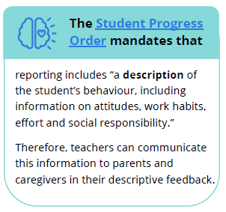
The purpose of British Columbia’s education system is to develop the “educated citizen.” The concept of a well-educated citizen can provide a guiding framework when thinking about student learning habits and engagement, since we aim to develop well-educated citizens who:

• Have a lifelong appreciation of learning
• Demonstrate curiosity about the world around them
• Have a sense of self-worth and personal initiative
• Have a sense of social responsibility
• Are flexible and able to deal with change
• Can make independent decisions
• Demonstrate acceptance and respect for the ideas and beliefs of others
• Have cultivated effective work habits to prepare them to achieve their career and occupational objectives

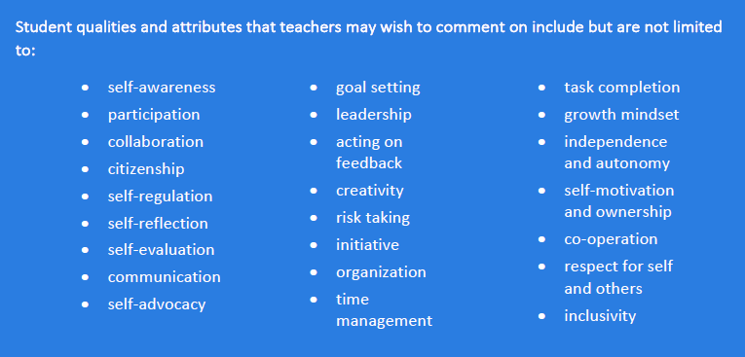

Optional sentence stems for descriptive feedback: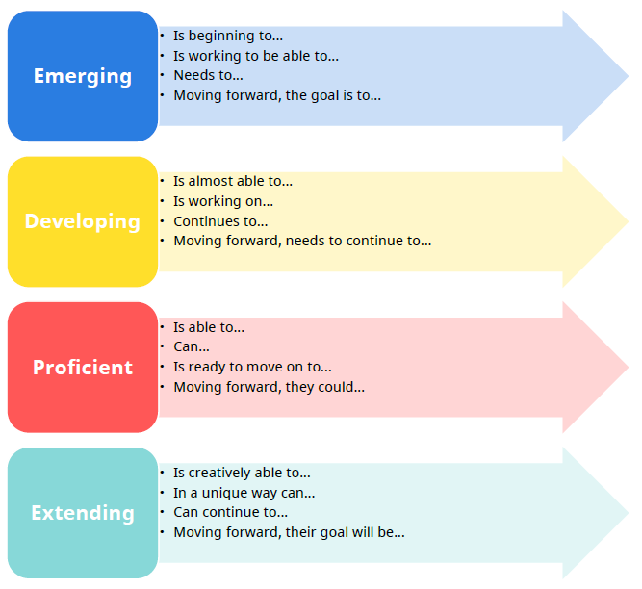

Example of descriptive feedback
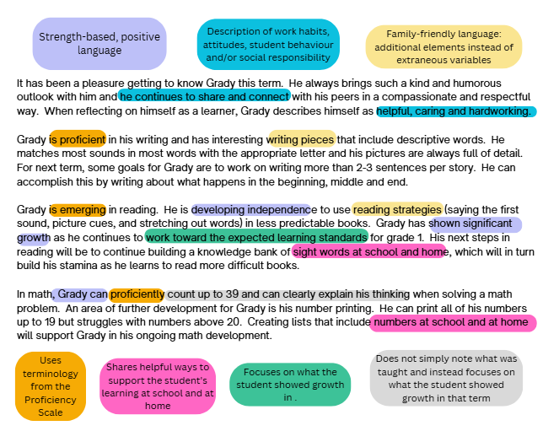

Example of descriptive feedback (cont.)

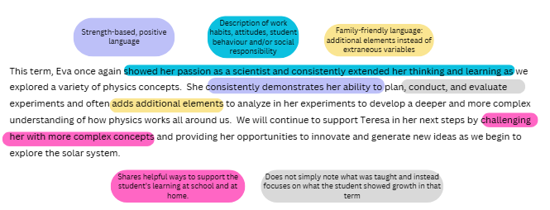

The pillars of education are Literacy & Numeracy. When we are communicating student learning it makes sense for the descriptive feedback to be more thorough (3-5 sentences max). For other subject areas it makes sense to be more brief 1-3 sentences max.
Please see the descriptive feedback examples below to help create succinct learning updates/summary of learning.
You will notice, learning outcomes are no longer communicated as part of the formal learning update. You are encouraged to communicate this information in weekly/monthly communications you send home or in a separate email.
The general criteria to include in descriptive feedback is: 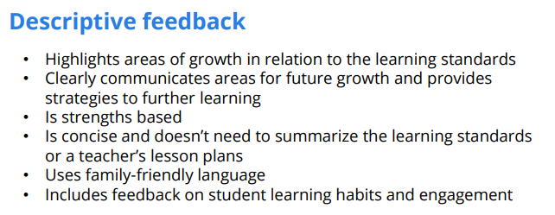
- ___________ is EMG/ DEV/ PROF/ EXT in ________ this term.
- Share what they do well/strengths – Choose 1-2 curricular/core competencies to comment on
- Share what they are working on (goals)
- Share how parent can support them at home (1-2 things)

Subject | Descriptive Feedback Example(s)
English Language Arts (Reading, Listening, Viewing | Primary Example:  _________ is emerging in reading. ___ is starting to access reading strategies such as saying the beginning sound, looking at the picture, and sounding out the word. _______ has shown significant growth as she engages with new text. Her next steps in reading will be to continue to build a knowledge bank of sight words at school and at home, and to build her stamina as she learns to read more difficult books.  Intermediate Example:  ________ is proficient in reading this term. She is becoming more expressive and tries hard to read carefully. She sounds out new words and fixes mistakes when the text does not make sense. Her next goal is to check her understanding as she reads to improve accuracy and comprehension. Reading a variety of books at home will help build her vocabulary and reading fluency.
English Language Arts (Writing, Speaking, Representing | Primary Example:  ___________ is proficient in writing and has created writing samples that include descriptive words and thoughtful sentences. She matches most sounds in most words with the appropriate letter and her illustrations are so detailed! For next term, a goal for _________ is to work on writing more than 2-3 sentences per story and make her writing more sequential by developing the beginning, middle, and end. She is encouraged practice journal writing at home.  Intermediate Example:  _________ is developing in writing, speaking, and representing. ____ has strong ideas and is becoming more confident sharing them, especially when the topic interests_____. ____ is working on writing clear, complete sentences and adding more details and describing words to explain ______ ideas better. At home, talking about ideas before writing and checking work together for clear sentences and added details will help build ____ confidence and skills.
Math | Primary Example:  __________ is proficient in math. ______ can count up to 39 and can clearly explain ____ thinking when adding to 20. An area of further development is skip counting by 2 and 5. _____can print all of ____ numbers up to 19 but struggles with numbers above 20. Creating lists that include numbers at school and at home will support _______ in ___ math development.  Intermediate Example:  __________ is developing math. He is beginning to build confidence with operations with integers, the order of operations, and patterns and relations. Additional modelling and step-by-step guidance will support further growth in these skills. With ongoing practice at school and at home, the use of visual supports such as tables and number lines, and continued review of key concepts, __________ will strengthen _____ foundational skills and progress toward greater independence in mathematical thinking.

Subject | Descriptive Feedback Example(s)
Social Studies | Primary Example:  ___________ is proficient in Social Studies this term. They like to share ideas and connections about communities and history, and are working on using evidence from texts and discussions to explain their thinking in more detail. Parents can support learning at home by talking about community and local history and encouraging their child to explain what they are learning at school.  Intermediate Example:  ___________ is developing in Social Studies this term. They are starting to explain ideas about historical events, governance, and Canadian society, and are increasingly more confident at making meaningful connections during class discussions. They are working on using evidence from texts and sources to support their responses more clearly; families can support at home by discussing current events or Canadian history and encouraging their child to explain and justify their thinking.
Science | _________ has demonstrated proficiency in science this term, showing a strong understanding of care for the environment and sustainability practices. _____ is aware of the challenges of climate change and recognizes the importance of making thoughtful, everyday choices that help protect the planet.
PHE | X participates positively and is proficient in PHE. They are developing basic movement skills and are willing to try new activities. X works well with others, shows good sportsmanship during games and understands the importance of staying active and making healthy choices.
ADST | X is proficient in ADST, showing interest in creating and designing projects. They are developing basic 3D design skills and can follow steps to create simple models.  ___________ is proficient in ADST, as ________ he was able to use _______ critical thinking skills to create a coding project that incorporated details such as sizing, and manipulating and combining objects. ________ is encouraged to use their skills and apply them to other projects.
Arts Ed. | Music  X is proficient in music, showing a growing understanding of rhythm and musical patterns. Continued practice reading music with different rhythm and patterns will help increase her musicianship.  ___________ demonstrated proficiency in Music through active participation and skill development on the ukulele. ________ shows confidence in coordinating rhythm, finger placement, and transitions between chords. Continued focus on smooth chord changes and expressive playing will help further strengthen her musicianship.  Visual Arts:  X has demonstrated proficiency in Visual Arts through creative exploration and collaborative performance projects. Throughout the term, she has reflected on her creative process and demonstrated growing confidence in sharing her work. Her willingness to take creative risks and work collaboratively has contributed positively to our arts community.

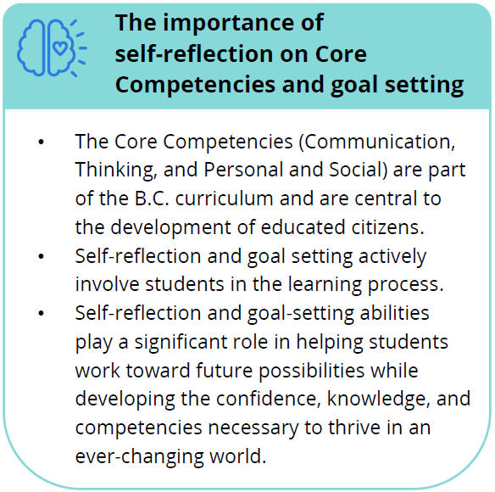

Core Competencies & Goal Setting
Self-reflection and goal setting are important parts of learning and development during K-12 years and beyond. Student self reflections on Core Competencies and student goal setting meaningfully involves students in the assessment process, amplifying student voice. Research shows student self-reflection leads to an increase in student confidence, abilities, and satisfaction.
We invite staff to use the SD20 Learns Goalsetting and Core Competencies Reflection Supports

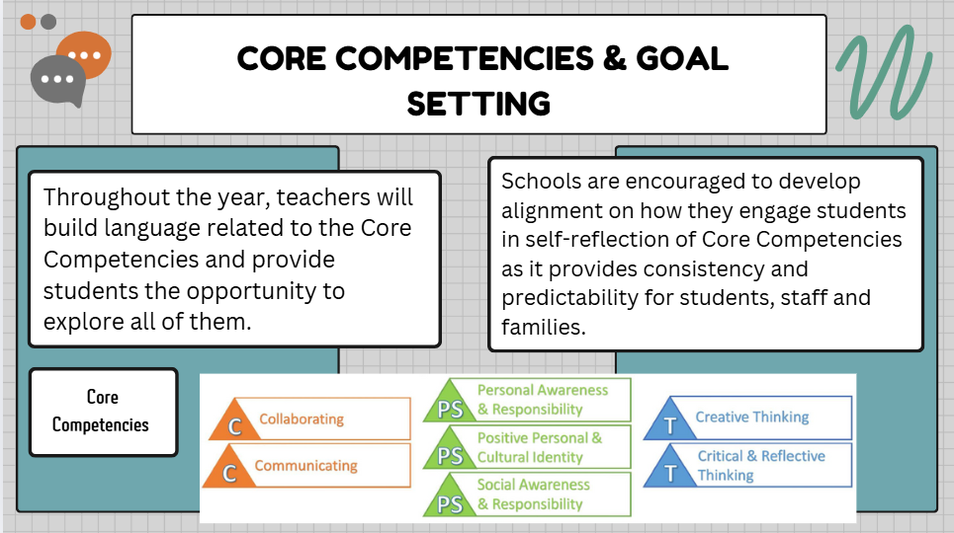

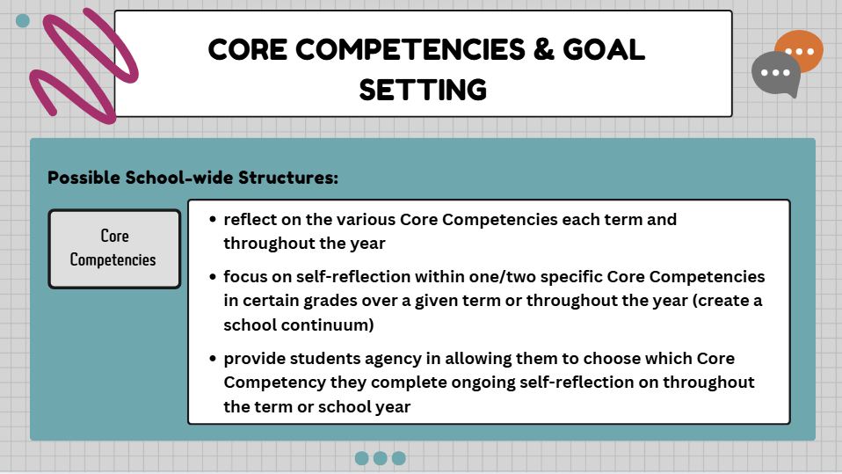
KCSD Learns invites teachers to click here to access templates for student reflections on Core Competencies.

Core Competencies & Goal Setting (cont.)

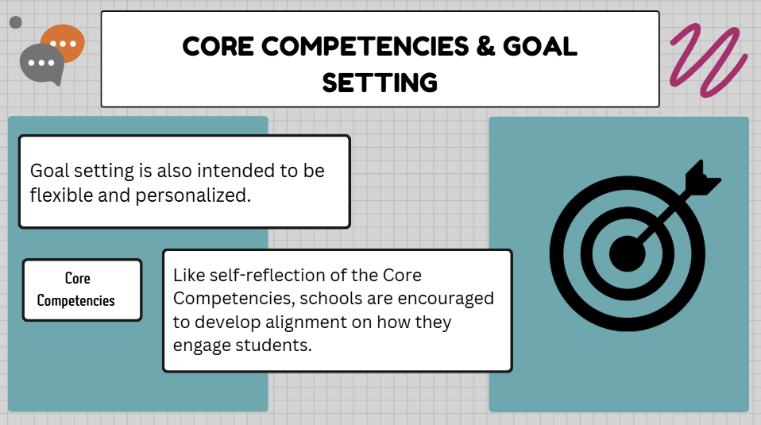

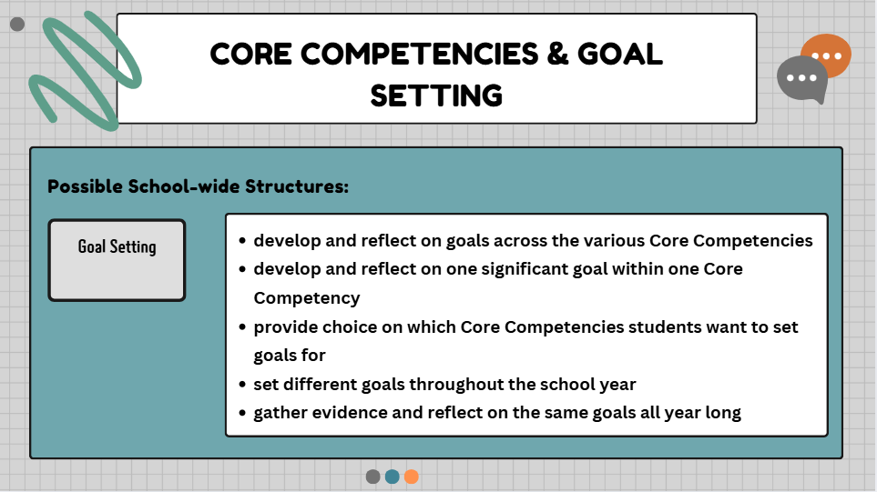

Engagement for Success
Noticing a students “Engagement for Success” is a way to inform parents about a student’s behaviours and efforts during learning.
Career Education has curricular competencies that align with the Communication and Personal and Social Core Competencies and we can utilize them to talk about “Engagement for Success.” For example, here is a snapshot of grade 4 level:
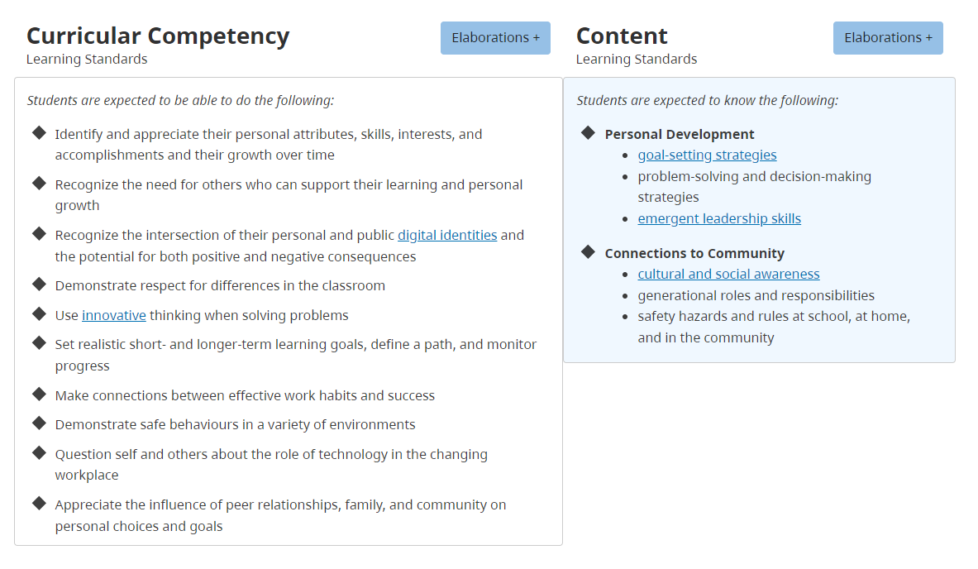
SD20 learns invites staff to click here to explore how the Career Education Language can be used to share Engagement for Success with parents/caregivers.

Considerations for Students on Individualized Education Plans (IEPs)
As with all other students, each Written Learning Update for a student on an IEP should describe the student's growth and next steps, as well as strategies/supports provided to support their ongoing learning.

A copy of the IEP does not need to go home with the Written Learning Update, given that a copy of a student’s IEP is sent home at the beginning and at the end of the school year, and any time signiﬁcant changes or updates are made to the goals/objectives in their IEP.

Written Learning Update requirements for learners with Disabilities or Diverse Abilities with an IEP:

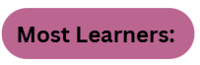
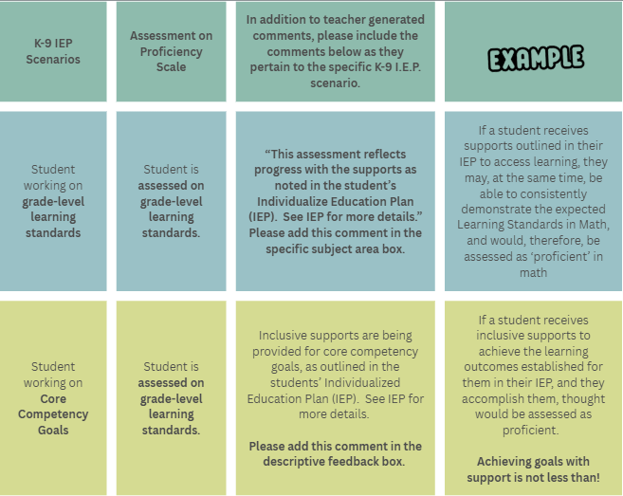

Reminder: Students working with the supports of an IEP may not necessarily be ‘emerging’ on the Proficiency Scale. If, with the supports noted in their IEP, they are showing grade-level proﬁciency they should be assessed as ‘proﬁcient’.

Considerations for Students on IEPs cont.
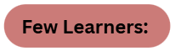
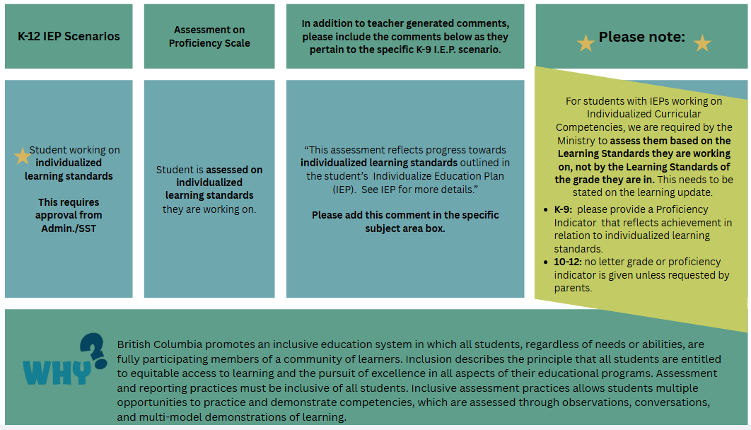

Considerations for English Language Learners
Students on an Annual Instruction Plan (AIP):

The following are student reporting guidelines for students who are accessing English Language Learning (ELL) supports. At each reporting period:

ELL Teachers:
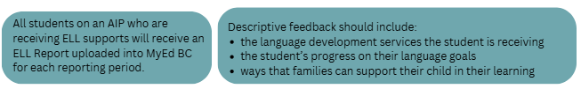

Considerations for English Language Learners cont.
Classroom Teachers:
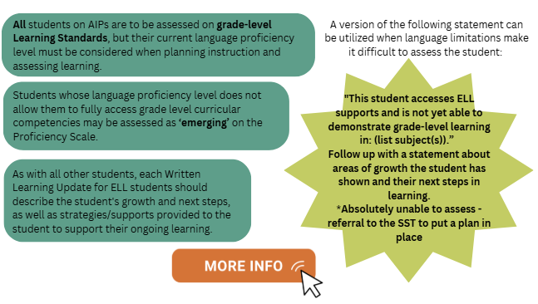

Considerations for Insufficient Evidence

It is rare to use the IE at the Elementary level.
When teachers do not have sufficient evidence of student learning due to special circumstances such as extended absences or personal challenges, the following procedure must be followed:

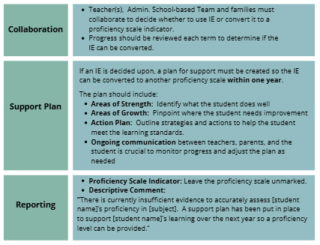

Formal Learning Update Guidelines:
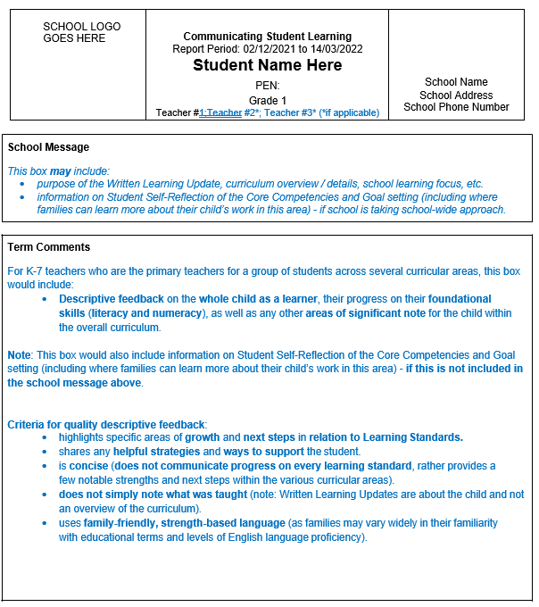
For K-5 teachers who are the primary teacher for students across several curricular areas, this box would include descriptive feedback on the whole child as a learner, their progress in Language Arts, Mathematics, Science, Social Studies, Physical Health Education and Arts Education. It may also include descriptive feedback on Core French (grade 5), Career Education, and Applied Design Skills & Technology.
For 6-7 teachers who are the primary teacher for students across several curricular areas, this box would include descriptive feedback on the whole child as a learner, and their progress in all subject areas.
This box would also include information on student self-reflection on the competencies and goal setting (including where families can learn more about their child’s work in this area) if this is not included in the school message above.

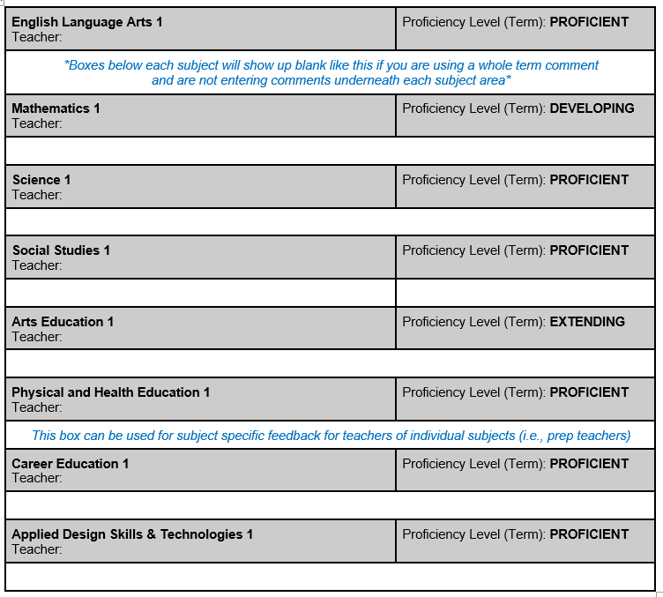

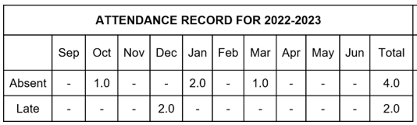

Formal Learning Update Example 1:

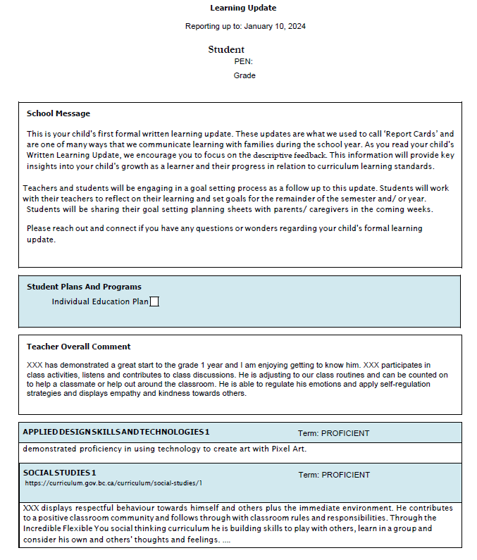

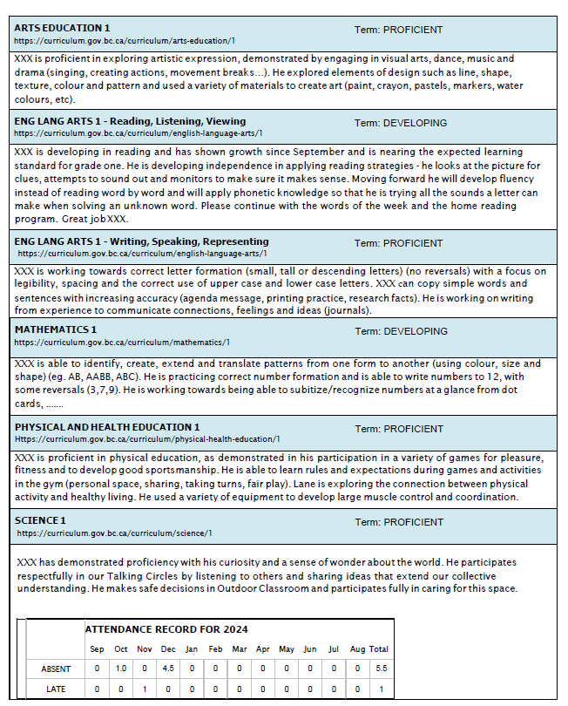

Formal Learning Update Example 2:

